Lab: REST Services and AJAX
Problems for in-class lab for the "JavaScript Applications" course @ SoftUni.

1. Trips Response
NOTE: Install "Postman" REST Client to ease your tasks.
Your first task is to get detailed information about Darth Vader.
- Send a "GET" request to the link given below.
- Copy the response in JSON format.
REQUEST:
https://trips-48955.firebaseio.com/trips/-M9ofHbIsyX0P8oOmUid.json

RESPONSE:
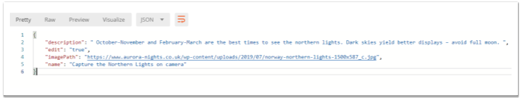

2. GitHub: Labels Issue
Get the first issue from repository with name “test-nakov-repo”. Send a GET request to https://api.github.com/repos/testnakov/test-nakov-repo/issues/:id, where :id is the issue.

3. Github: Create Issue
This time we have to create an issue (data should be send to the server). Send a "POST" request to the server with the following JSON as body (send it as application/json):
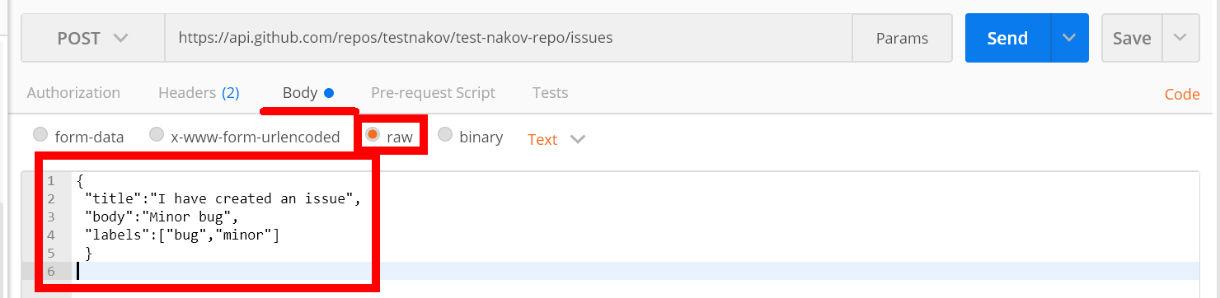
You need to use your GitHub account credentials to submit issues. Under the Authorization tab, select Basic and enter your username and password. Send the request to the URI from the previous task, but without the :id.

4. XHR (XmlHttpRequest)
Your task is to write a JS function that loads a github repository asynchronously with AJAX. You should create an instance of XmlHttpRequest and attach an onreadystatechange event to it. (An EventHandler that is called whenever the readyState attribute changes). In your event handler, when the readyState attribute reaches a value of 4 (it is ready), replace the text content of a div element with id "res" with the value of the responseText property of the request. Do not format the response in any way.
More on XmlHttpRequest.open()
Skeleton will be provided in the Resources folder.

Examples
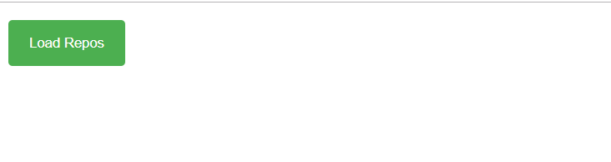
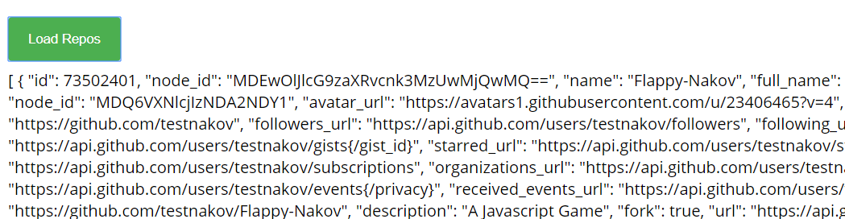

5. Github Repos
Your task is to write a JS function that executes an AJAX request with Fetch API and loads all user github repositories by a given username (taken from an input field with id "username") into a list (each repository as a list-item) with id "repos". Use the properties full_name and html_url of the returned objects to create a link to each repo’s GitHub page. If an error occurs (like 404 “Not Found”), append to the list a list-item with text the current instead. Clear the contents of the list before any new content is appended. See the highlighted lines of the skeleton for formatting details of each list item.
Skeleton will be provided in the Resources folder.

Examples
